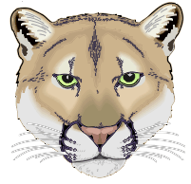
Clark Middle School Cougar Band
4600 Colby Drive Frisco, TX. 75035
Katzb@friscoisd.org
469-633-4621
www.clarkband.org

Beginning Band Fall Concert
Thursday, November 9th, at 6:00PM
Clark Cafeteria

Free Admission

All Beginning Band members need to be seated in the band hall for pictures by 5:30. Concert begins at 6:00PM. Leave your instrument and music in your locker until after pictures. When we travel to the cafeteria to perform, please leave your cases by your locker in the band hall.

Attire: Cougar Band Shirts, tucked in, with long pants or nice shorts, or skirt (No Jeans)

Grading: Students will be given THREE grades that evening:
- Performance Grade
- Preparation Grade (including uniform)
- Etiquette Grade
To receive FULL CREDIT for the concert, students must stay for the entire concert so they may learn from their peers.

Parents: This is our ONLY Public performance until MAY. Please bring friends, family and neighbors to see what your young musician can do!!! Video Cameras welcome!

SEE YOU THERE!!

