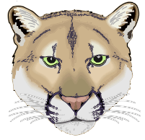
Clark Middle School Cougar Band
4600 Colby Drive Frisco, TX. 75035
KatzB@Friscoisd.org
469-633-4621
www.clarkband.org

Greetings:

This is a reminder letter that the annual spring awards concert is Tuesday, June 2nd. We are performing at Clark Middle School.

Students are expected to arrive at 5:30pm. The Concert Band will meet on stage, with the Honor Band in the Choir Room, and the Symphonic Band in the Band Hall. Students are expected to dress up! This is an awards concert and we want to look our best. No jeans, or athletic shoes, please. Attendance is mandatory. Selected students from each band will be recognized for their achievements!

The Concert begins at 6:00pm and should conclude around 8:00PM. There will be a slide show afterwards. See you Tuesday night!! Please contact us at KatzB@friscoisd.org or call at 469-633-4621 if you have any questions or concerns.

