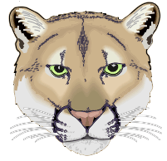
Clark Middle School Cougar Band
4600 Colby Drive Frisco, TX. 75035
KatzB@Friscoisd.org
469-633-4621
www.clarkband.org

Spring Concert

Who: Concert, Honor and Symphonic Bands

When: Tuesday, May 22nd at 5:30PM; Concert at 6:00PM

Where: Clark Middle School Cafeteria.

What to wear:

- Students are expected to wear their nicest “red carpet” style clothing. Boys may wear a suit, or a coat and tie, or khakis and a button-down shirt.
- Girls may wear dresses or nice pants and a blouse.
  - No jeans, t-shirts or athletic shoes please.
- Selected students from each band will be recognized for their achievements.

Attendance is mandatory:

- The Concert begins at 6:00pm and should conclude around 7:30PM. See you Tuesday, May 22nd at 5:30PM
- The concert is required and has been on the calendar for the entire year.
- Students will receive three major grades for the event.
  - Preparation, Performance, Etiquette

Please contact us at KatzB@friscoisd.org or if you have any questions or concerns.

