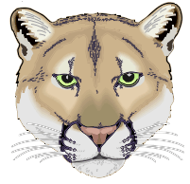
Clark Middle School Cougar Band
4600 Colby Drive Frisco, TX. 75035
469-633-4621
www.clarkband.org

Dear Parents:

On Thursday, October 18th, all 8th grade students that are going to Centennial HS are expected to play with the Centennial High School Band, at the Star. We are meeting, at the Clark Band Hall, at 5:00pm. Students are expected to wear their band t-shirt, jeans, or shorts, and athletic shoes. We are leaving on buses, at 5:15pm. We will march in with the Band at 6:00pm.

- We are leaving on buses, at 5:15pm.
- We will march in with the Band at 6:00pm.
- All 8th grade students are expected to attend.
- Volleyball is excused.
- We are staying for the entire game
- If you need to leave early, then I must have a note

Please eat dinner before you come to the event. We are only serving drinks and a snack. Students are not allowed to go to the concessions stands. Students are allowed to bring their homework to the event. We are leaving after halftime. Only a legal guardian may pick up a student from the event.

If you have any questions or concerns, please contact us. See you at the game!!

Benjamin Katz
Head Band Director
katzb@friscoisd.org
469-633-4621

